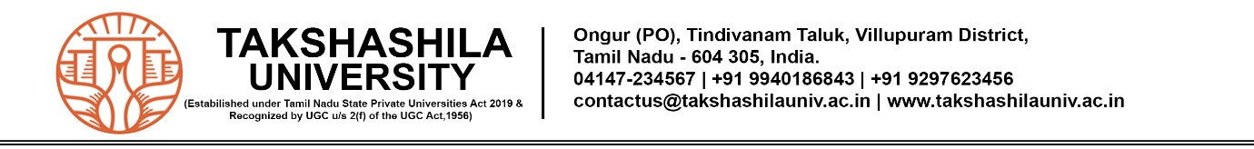

**MARK STATEMENT FOR CONTINUOUS ASSESSMENT TEST-I, SEPTEMBER 2025**

|  |  |  |  |
| --- | --- | --- | --- |
| FACULTY |  | BATCH |  |
| SCHOOL |  | ACADEMIC YEAR |  |
| DEPARTMENT |  | YEAR/SEMESTER |  |
| PROGRAMME |  | SECTION |  |
| COURSE NAME |  | COURSE CODE |  |

|  |  |  |  |  |  |
| --- | --- | --- | --- | --- | --- |
| **No** | **Enrolment No.** | **Name of the Student** | **Test** | **MCQ** | **Assign** |
|  |  |  |  |  |  |
|  |  |  |  |  |  |
|  |  |  |  |  |  |
|  |  |  |  |  |  |
|  |  |  |  |  |  |
|  |  |  |  |  |  |
|  |  |  |  |  |  |
|  |  |  |  |  |  |
|  |  |  |  |  |  |
|  |  |  |  |  |  |
|  |  |  |  |  |  |
|  |  |  |  |  |  |
|  |  |  |  |  |  |
|  |  |  |  |  |  |
|  |  |  |  |  |  |
|  |  |  |  |  |  |
|  |  |  |  |  |  |
|  |  |  |  |  |  |
|  |  |  |  |  |  |
|  |  |  |  |  |  |

**Course In-charge School In-charge Dean – FSC & FHSS**